****

****

CONFLICT RESOLUTION

**November 2022**

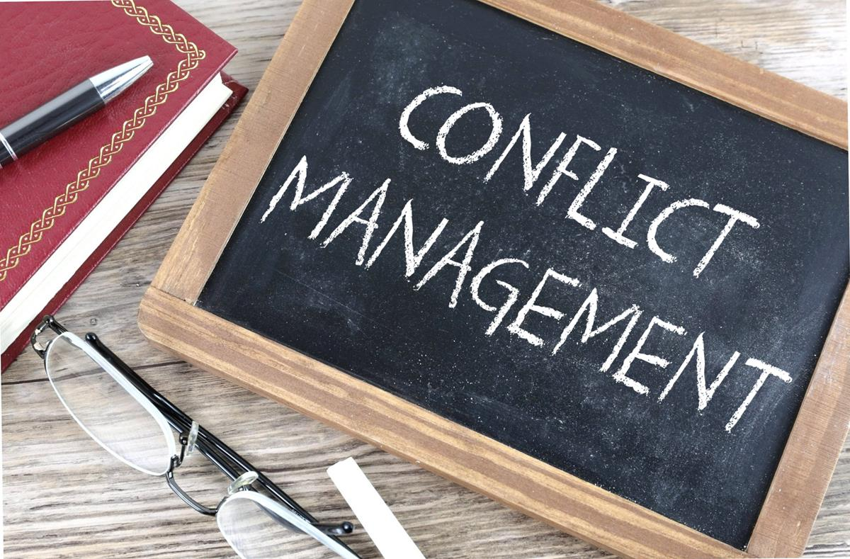

**Designed and delivered by**

**Patricia C. Borne, Executive Principal**

859.802.5036 [resourzes@aol.com](mailto:resourzes@aol.com) [www.ceo-resources.com](http://www.ceo-resources.com)

[](http://ceo-resources.com/)

**CONFLICT RESOLUTION WORKSHOP**

**BD21318_**

The principles of conflict resolution will be discussed, and a successful nine-step approach will be practiced. The value of “I” statements will be reviewed, and employee expectations will be investigated.

**Learning Objectives:**

* understand principles of conflict
* discover nine-step process for resolving disputes
* communicate effectively through "I" statements
* practice conflict resolution skills
* investigate 12 challenging personalities

## Agenda:

Conflict Modes

Three Principles of Conflict

Conflict Acrostic

Eight Major Causes of Work-Related Conflict

Employee/Supervisor Expectations

“The Dirty Dozen”

#### Listening Principles

Nine Steps Method for Resolving Conflict

Conflict Resolution Scenario Exercise

****

**BD21318_**

***Methodologies*:** - Lecturettes - Role play - Small Group Practice

*Materials designed and provided by CEO Resources are proprietary and exclusive. They can be used, copied and delivered only through the written authorization of the executive principal.*

**THREE PRINCIPLES OF CONFLICT**

**ATTRIBUTES OF CONFLICT**

**NEGATIVE**  **POSITIVE**

**BD21318_**

**C \_\_\_\_\_\_\_\_\_\_\_\_\_\_\_\_\_\_\_\_\_\_\_\_\_\_\_\_\_\_\_ C\_\_\_\_\_\_\_\_\_\_\_\_\_\_\_\_\_\_\_\_\_\_\_\_\_\_\_\_**

**O \_\_\_\_\_\_\_\_\_\_\_\_\_\_\_\_\_\_\_\_\_\_\_\_\_\_\_\_\_\_\_ O\_\_\_\_\_\_\_\_\_\_\_\_\_\_\_\_\_\_\_\_\_\_\_\_\_\_\_\_**

**N \_\_\_\_\_\_\_\_\_\_\_\_\_\_\_\_\_\_\_\_\_\_\_\_\_\_\_\_\_\_\_ N\_\_\_\_\_\_\_\_\_\_\_\_\_\_\_\_\_\_\_\_\_\_\_\_\_\_\_**

**F \_\_\_\_\_\_\_\_\_\_\_\_\_\_\_\_\_\_\_\_\_\_\_\_\_\_\_\_\_\_\_ F\_\_\_\_\_\_\_\_\_\_\_\_\_\_\_\_\_\_\_\_\_\_\_\_\_\_\_\_**

**L \_\_\_\_\_\_\_\_\_\_\_\_\_\_\_\_\_\_\_\_\_\_\_\_\_\_\_\_\_\_\_ L\_\_\_\_\_\_\_\_\_\_\_\_\_\_\_\_\_\_\_\_\_\_\_\_\_\_\_\_**

**I \_\_\_\_\_\_\_\_\_\_\_\_\_\_\_\_\_\_\_\_\_\_\_\_\_\_\_\_\_\_\_ I\_\_\_\_\_\_\_\_\_\_\_\_\_\_\_\_\_\_\_\_\_\_\_\_\_\_\_\_**

**C \_\_\_\_\_\_\_\_\_\_\_\_\_\_\_\_\_\_\_\_\_\_\_\_\_\_\_\_\_\_ C\_\_\_\_\_\_\_\_\_\_\_\_\_\_\_\_\_\_\_\_\_\_\_\_\_\_\_**

**T \_\_\_\_\_\_\_\_\_\_\_\_\_\_\_\_\_\_\_\_\_\_\_\_\_\_\_\_\_\_ T\_\_\_\_\_\_\_\_\_\_\_\_\_\_\_\_\_\_\_\_\_\_\_\_\_\_\_\_**

*Materials designed and provided by CEO Resources are proprietary and exclusive. They can be used, copied and delivered only through the written authorization of the executive principal.*

**8 MAJOR CAUSES OF WORK-RELATED CONFLICT**

**BD21318_**

1. Work itself
2. How work gets assigned
3. The way supervisors interact with employees
4. Perception of unfairness
5. Lack of information
6. Changes not explained
7. Harsh criticism
8. Favoritism

**EMPLOYEE EXPECTATION SUPERVISOR EXPECTATION**

**BD21318_**

**Interesting work Quality and quantity of work**

**Fairness Productivity**

**Help from supervisor Dependability**

**Good pay and benefits Cost control**

**Friendly relations with other employees Support for company goals**

**Opportunity to learn and advance Honesty/Loyalty**

**Some autonomy/authority for work Follow company rules**

**Recognition Ability to work as team member**

**Job security Adaptability/responsibility**

**Trust in supervisor Support for supervisor’s decisions**

*Materials designed and provided by CEO Resources are proprietary and exclusive. They can be used, copied and delivered only through the written authorization of the executive principal.*

**THREE TYPES OF LISTENING**

**BD21318_**

**CONTENT INTUITIVE EMPATHETIC**

1. Stop talking.

2. Put the speaker at ease.

3. Show him/her you want to listen.

4. Remove distractions.

5. Empathize with him/her.

6. Be patient.

7. Hold your temper.

8. Go easy on argument and criticism.

9. Ask questions.

10. Stop talking.

**NINE STEPS TO EFFECTIVE CONFLICT MANAGEMENT**

1. Identify the issue.

2. Write down your feelings.

3. Decide how and where to present your complaint/frustration.

4. Make certain you know what you want out of the situation.

5. State your complaint briefly.

6. Listen with an open mind.

7. Avoid YOU statements.

8. Take time out for reflection.

9. Make a plan (take action or proceed with chain of command).

*Materials designed and provided by CEO Resources are proprietary and exclusive. They can be used, copied and delivered only through the written authorization of the executive principal.*

**CONFLICT SCENARIO – WORKPLACE**

**j0303965**

* two co-workers share a common work area
* one worker is very well organized, the other, sloppy
* they do not work continuously with each other, but have a 30-minute overlap when the shift changes
* they both complain about each other, but neither knows how to confront and resolve the issue

Participants, work in small groups, take this scenario, apply the nine-step approach and report back to the larger group with dialog and solutions.

Example:

1. Identify the Issue – differing workstyles

2. Write down feelings – fear of confronting, frustration, anger, etc.

*Materials designed and provided by CEO Resources are proprietary and exclusive. They can be used, copied and delivered only through the written authorization of the executive principal.*

****

**“I” STATEMENTS**

**Seven Steps for Communicating Effectively Using “I” Statements**

1. By using “I” we avoid defensive reactions from others.
2. By using “I” we take responsibility for our own feelings.
3. By using “I” we convey clear messages.
4. By using “I” we can encourage dialogue and initiate problem-solving.
5. By using “I” we can eliminate angry or sarcastic responses.
6. By using “I” we avoid using words that can hurt others.
7. By using “I” we save time.

*Materials designed and provided by CEO Resources are proprietary and exclusive. They can be used, copied and delivered only through the written authorization of the executive principal*