**Disruption Map**

Uncover the themes and patterns that show up across your life—not just the 'work you,' but the whole you. By surfacing strengths, passions, and experiences from both your personal and professional worlds, you’ll start to spot the throughlines that fuel your growth, fulfillment, and direction.

|  |  |  |  |
| --- | --- | --- | --- |
|  | **Strengths**  What you’re annoyingly good at—even if you don’t try. What do people consistently count on you for? | **Passions**  The stuff that lights you up or makes you rant at parties. What topics or activities make you lose track of time? | **Experiences**  The chapters you’ve lived—good, bad, or brag-worthy. What moments have shaped how you show up today? |
| **Personal** | *e.g., Coaching, organizing events* | *e.g., Travel, hosting, mentoring* | *e.g., Volunteering, parenting, leading trips* |
| **Professional** | *e.g., Asking good questions, leading meetings* | *e.g., Helping people solve problems, team leadership* | *e.g., Launching programs, managing people* |

Circle shared themes across all of the boxes. Get creative to see the connections. Give each cluster a name below:

|  |  |
| --- | --- |
| **Cluster Name** | **What is in It** |
|  |  |
|  |  |
|  |  |

**Mirrored Disruption**

We all have “mirrors” in our lives—the people who reflect back truths we might be avoiding. Sometimes they challenge us. Sometimes they annoy us. Sometimes they see our potential before we do.

This activity invites you to name those people who help (or need to help) disrupt your current self-perception—for better or worse. These are the folks who make you think twice, question your patterns, or push you toward growth. You’re not just naming people—you’re surfacing the stories you tell yourself... and deciding which ones to disrupt.

Consider the personas above and think of the people in your life. Whose critical perspective(s) are you failing to take into account?

|  |  |  |
| --- | --- | --- |
| **Person in my Life** | **Persona Above they Connect to** | **What Should I ask them?** |
|  |  |  |
|  |  |  |
|  |  |  |
|  |  |  |

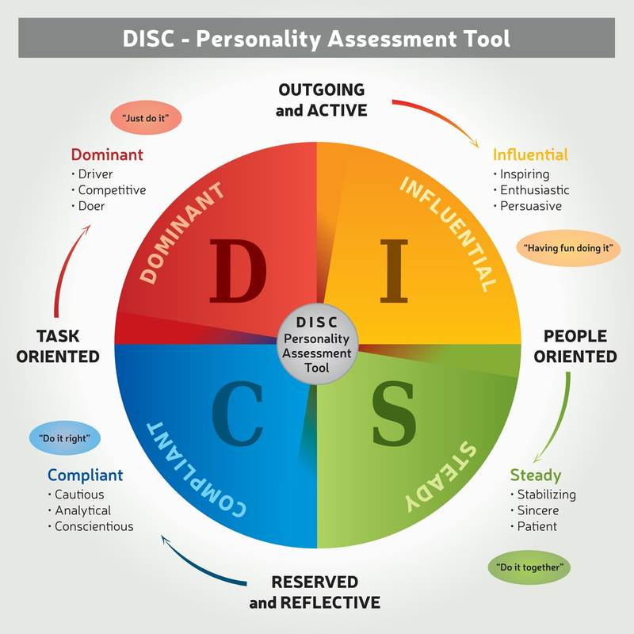

**Talking to a High D**

* They need to feel in control / lead …*remember that but also show confidence as they respect it.*
* They are TASK oriented…*show how you make them win better, faster etc. than without you.*
* Be ‘to the point’ …*be direct in your communication.*
* *High D’s make decisions, so ask them for one positively.*

**Talking to a High I**

* They need to feel there is a relationship…if they are not valued as a person, this will come across.
* Show them that you care about them. Speak in lighter tones…as though with a friend.
* Let them speak, try and be open. They enjoy conversing, and will want to know about you, not just what you do.
* They will make decisions, often based on the person and how much they like them

**Talking to a High S**

* They need to TRUST you, and your offering.*Take it slow and show proof and character.*
* They will not respond well to being put on the spot. *Where possible, position them on when the decision point is expected, and what information you’ll give to support that.*
* Like the ‘I’s, they value relationship, so be their friend.

**Talking to a High C**

* They need to have the details to feel comfortable. *It is likely they will have lots of questions. Answer them or give supporting evidence ahead of time.*
* Provide case studies, examples, and direct evidence that relates to THEIR circumstance.
* Tough to close, but follow up consistently, and help them decide with solid proof.

